**Fatima Jinnah Women University**

Department of Software Engineering

**LAB 7**

**Name:** Raifa Khalid

**Reg. no:** 2020-BSE-024

**Section:** A

**Semester:** Fourth

**Course:** Data Base (LAB)

**EXAMPLES:**

*Cartesian Product:*

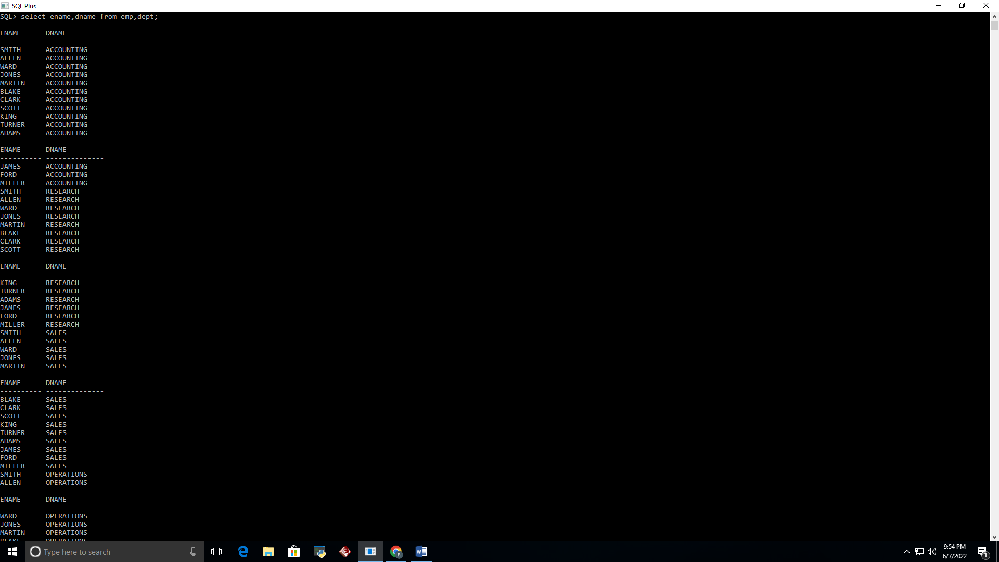

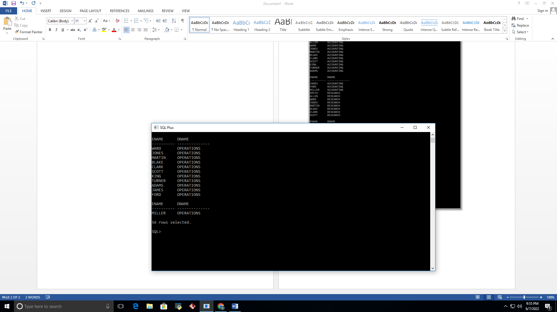

*Equijoin:*

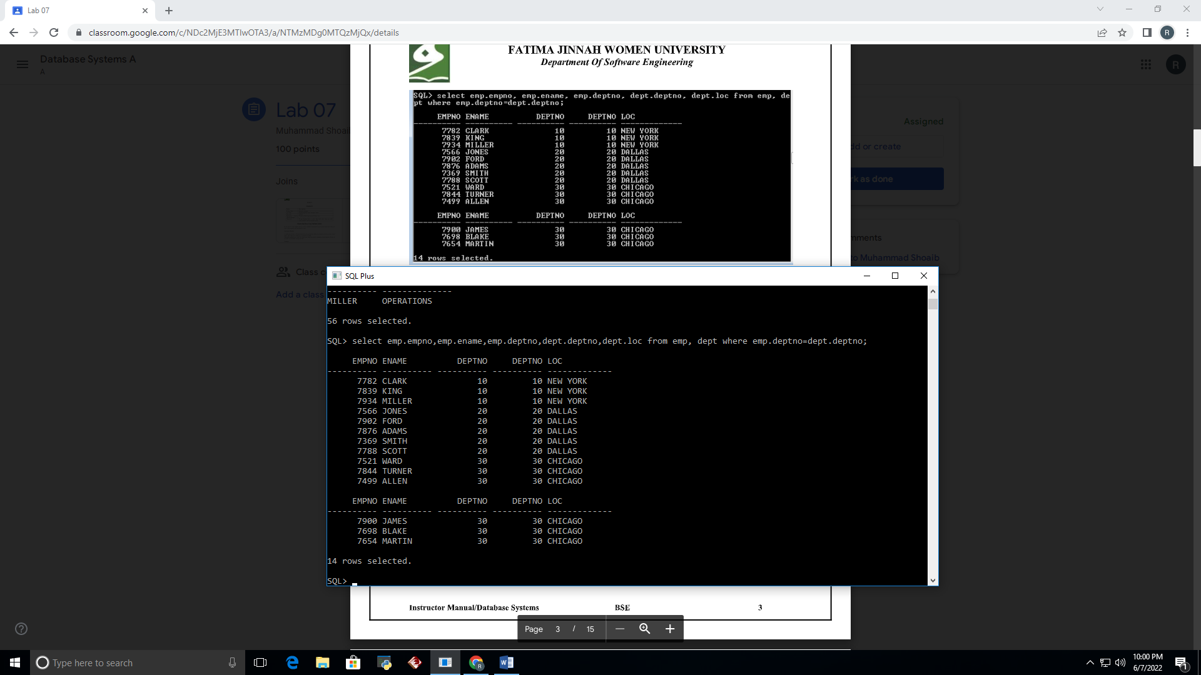

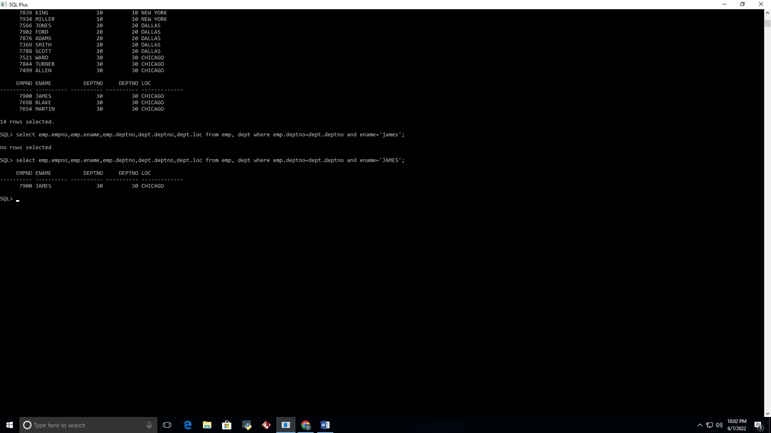

*Using Table Alias:*

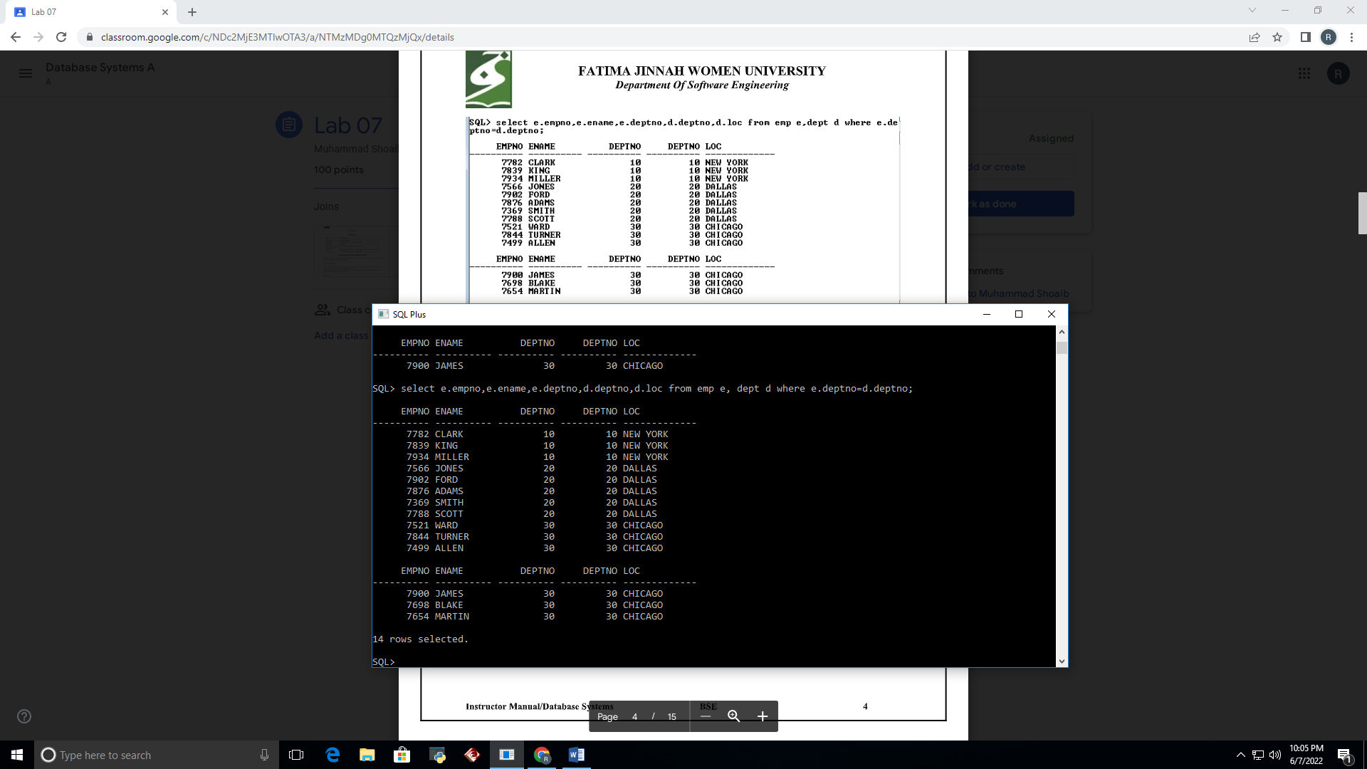

*Non Equijoin:*

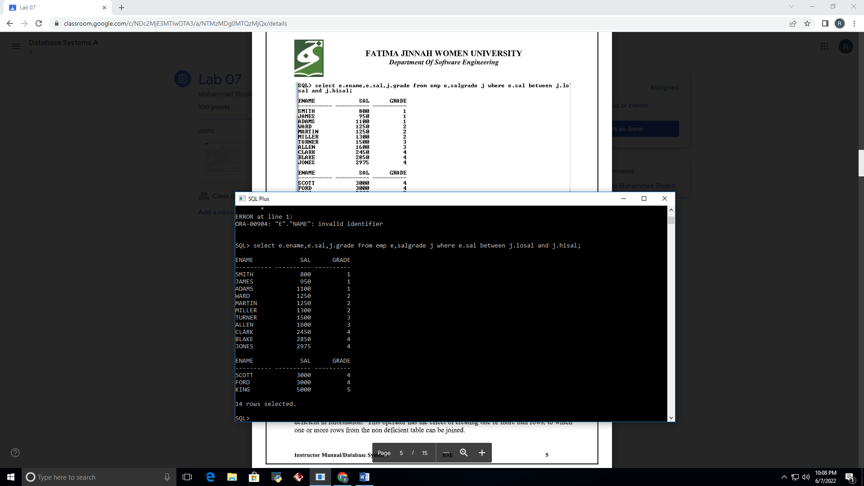

*Outer Join:*

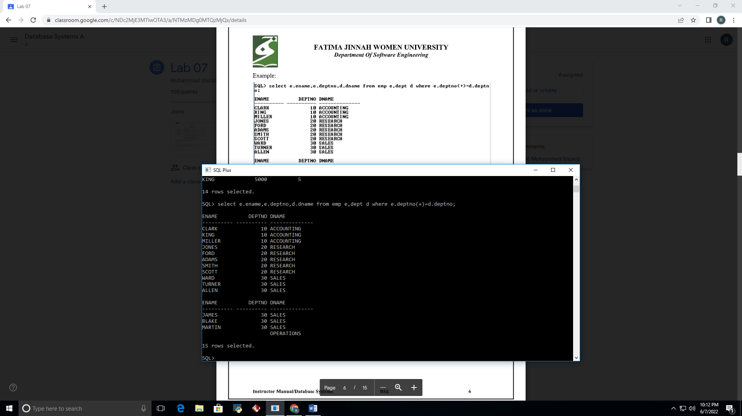

*Self Join:*

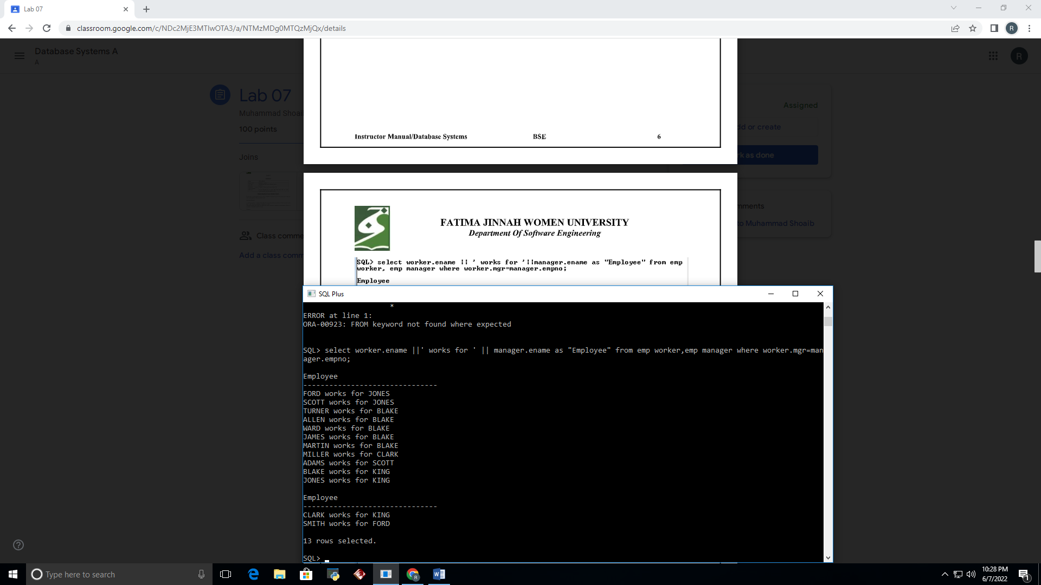

*Creating Cross Joins:*

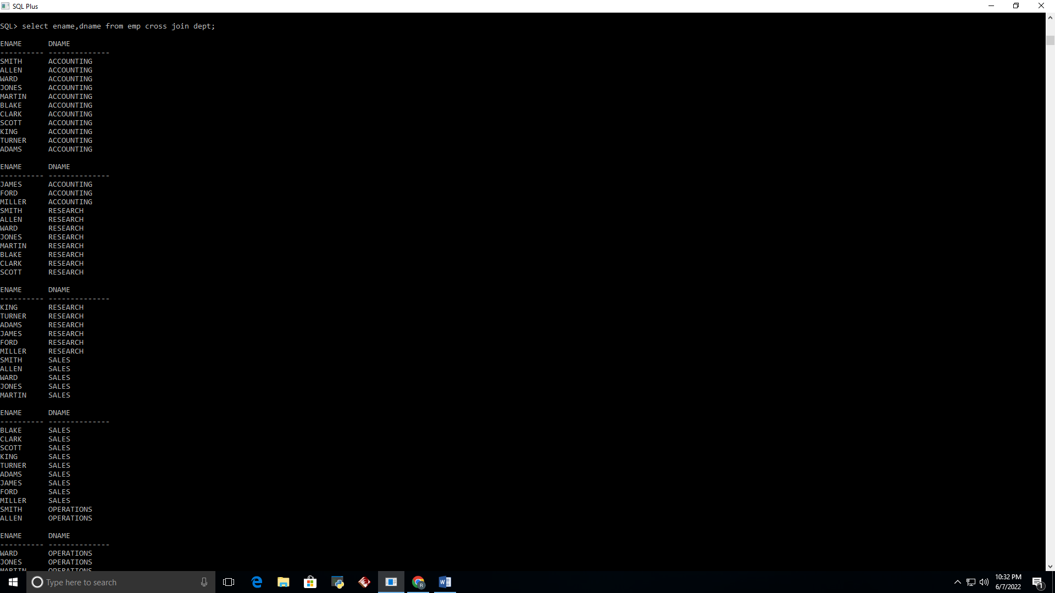

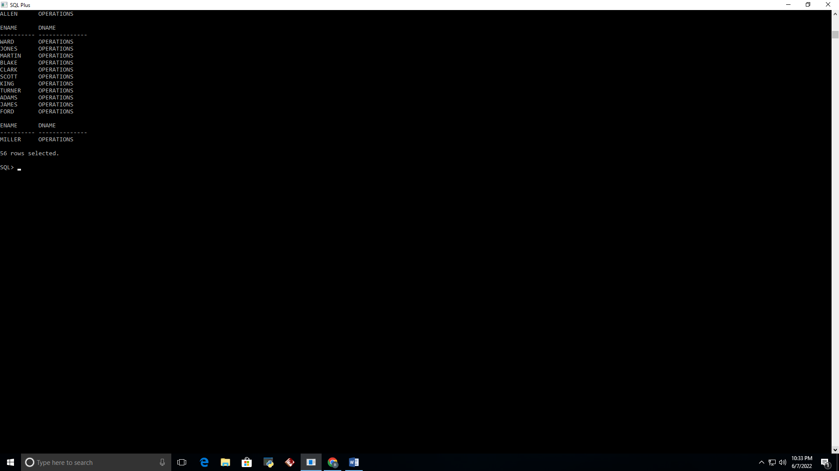

*Creating Natural Joins:*

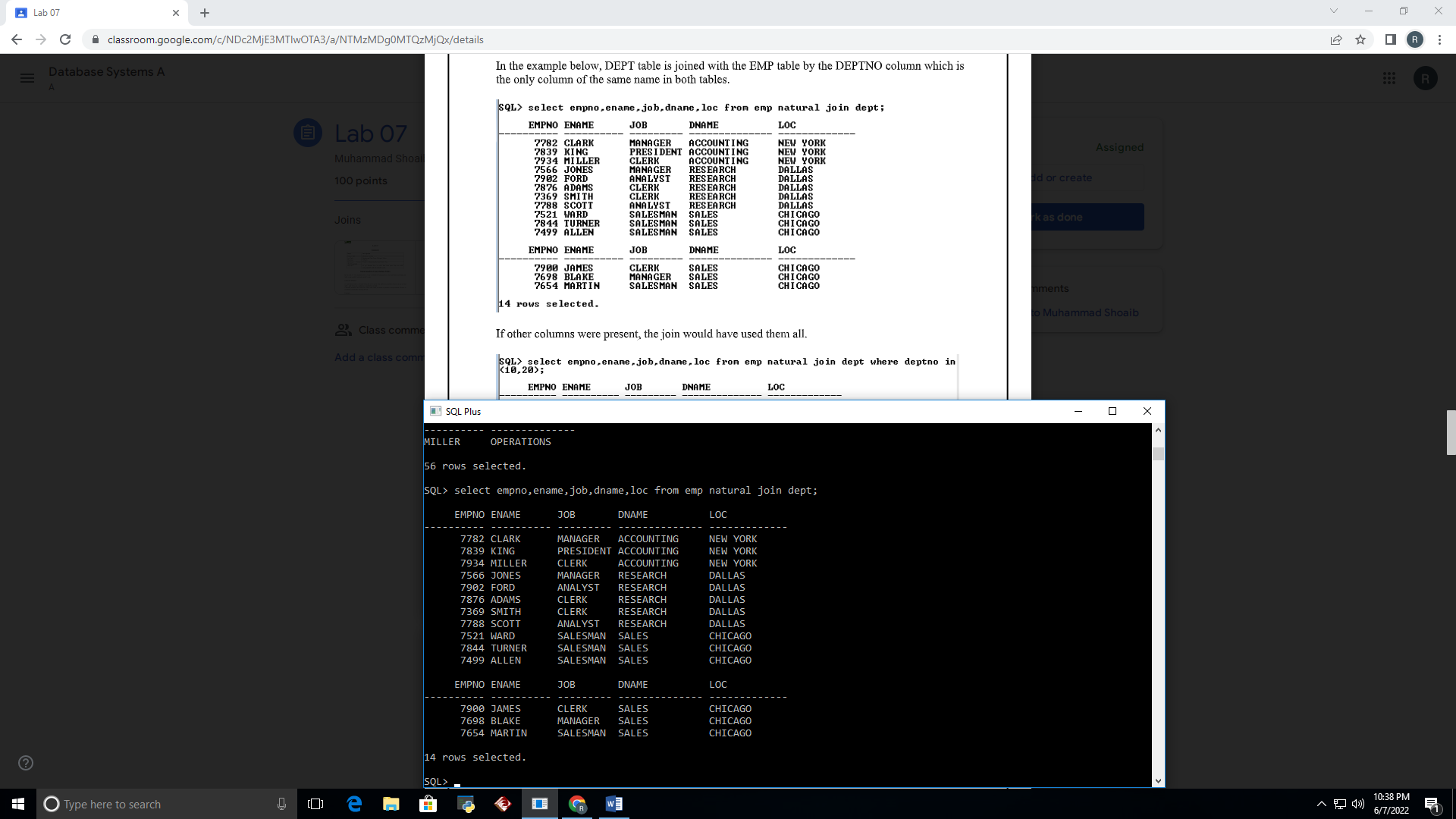

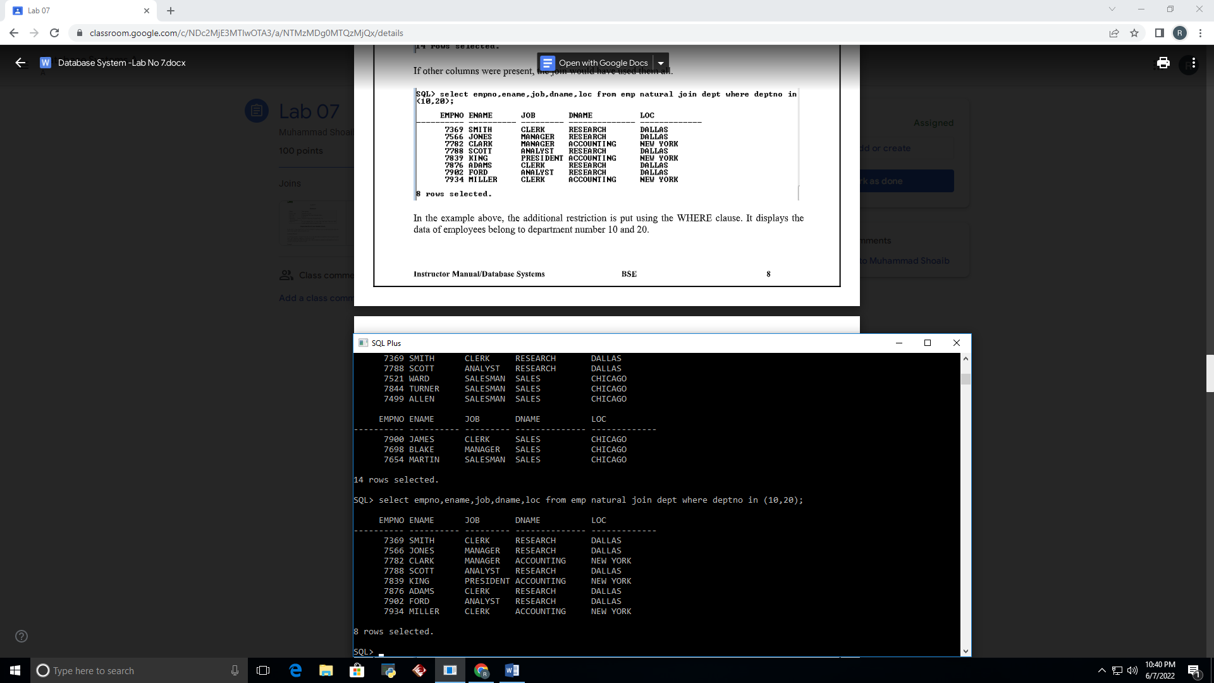

*Creating Joins with the USING clause:*

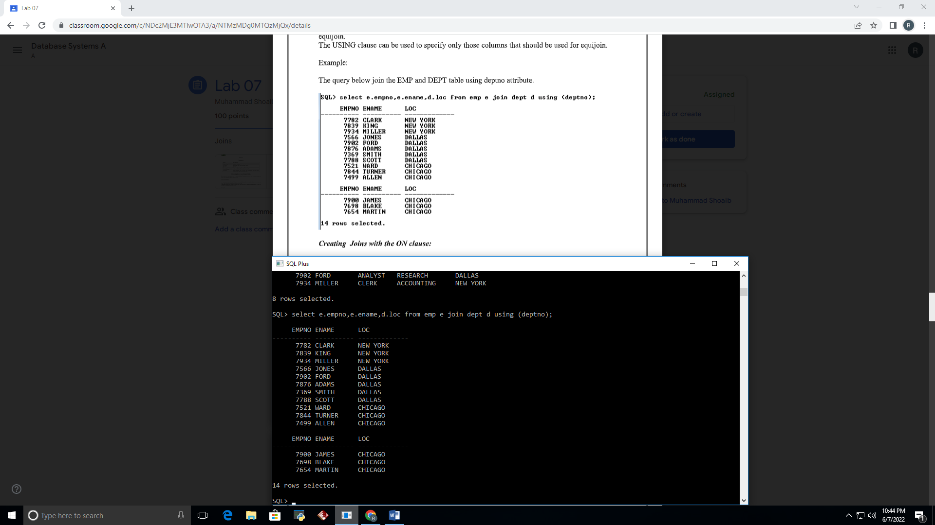

*Creating Joins with the ON clause:*

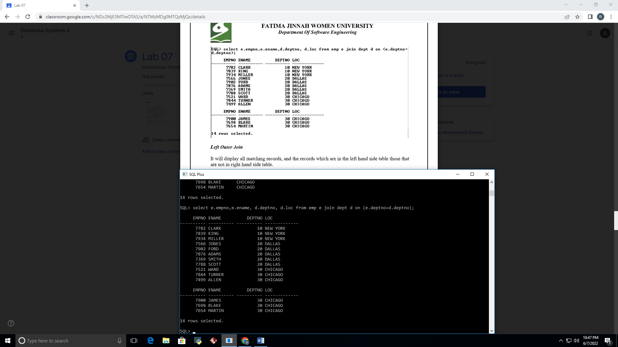

*Left Outer Join:*

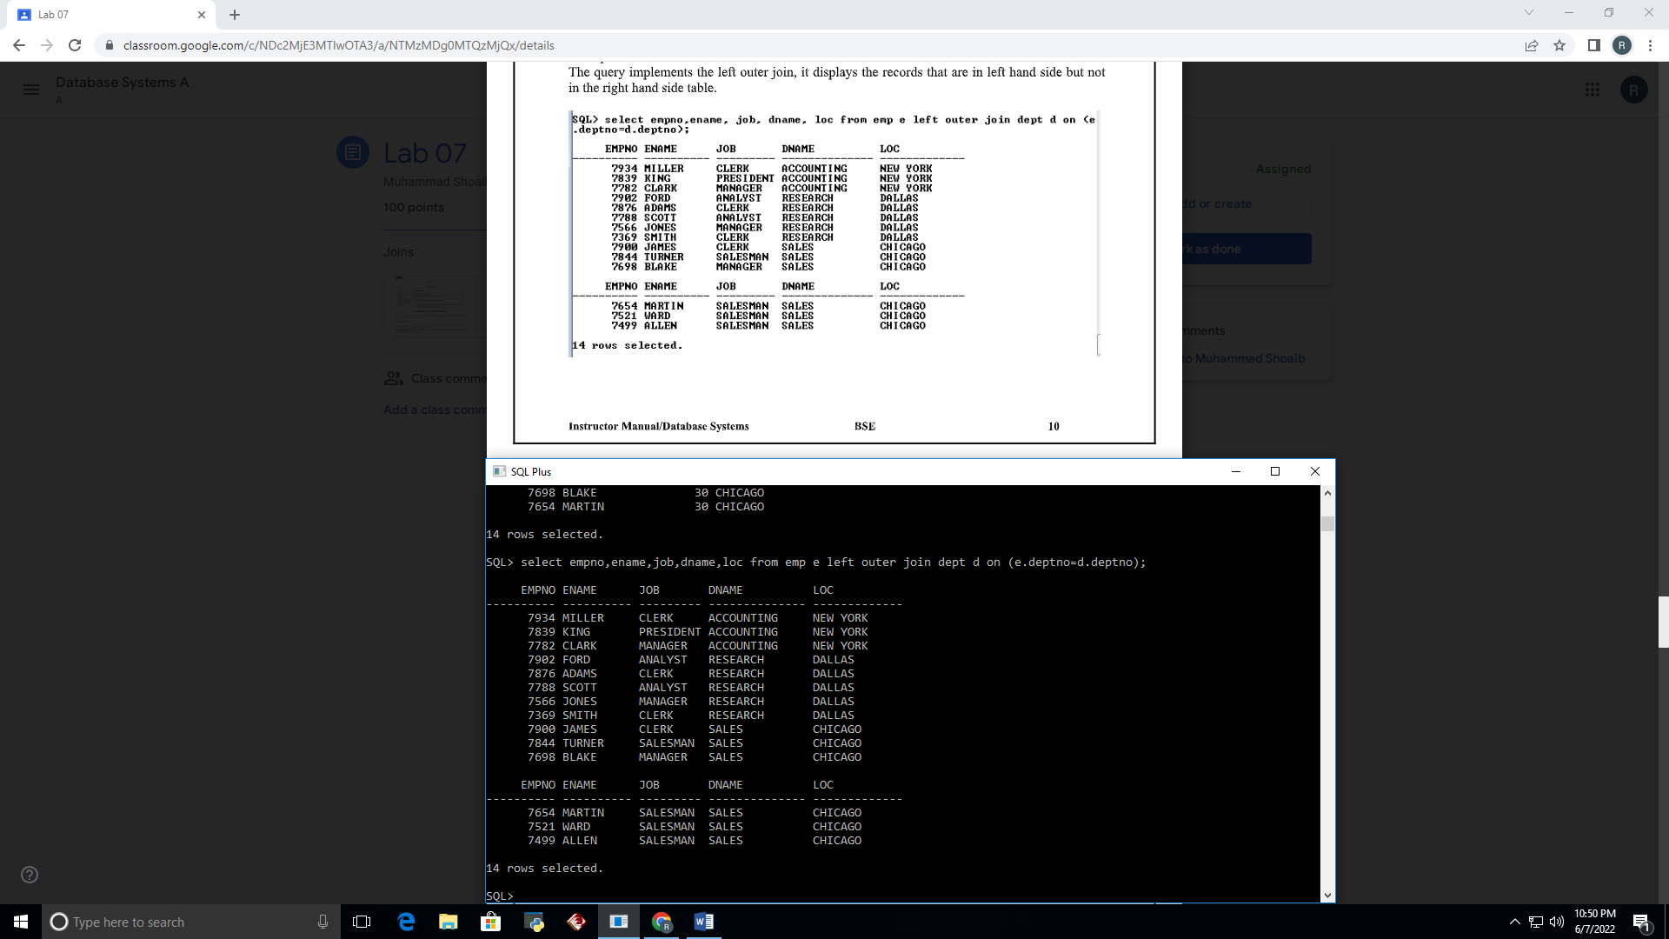

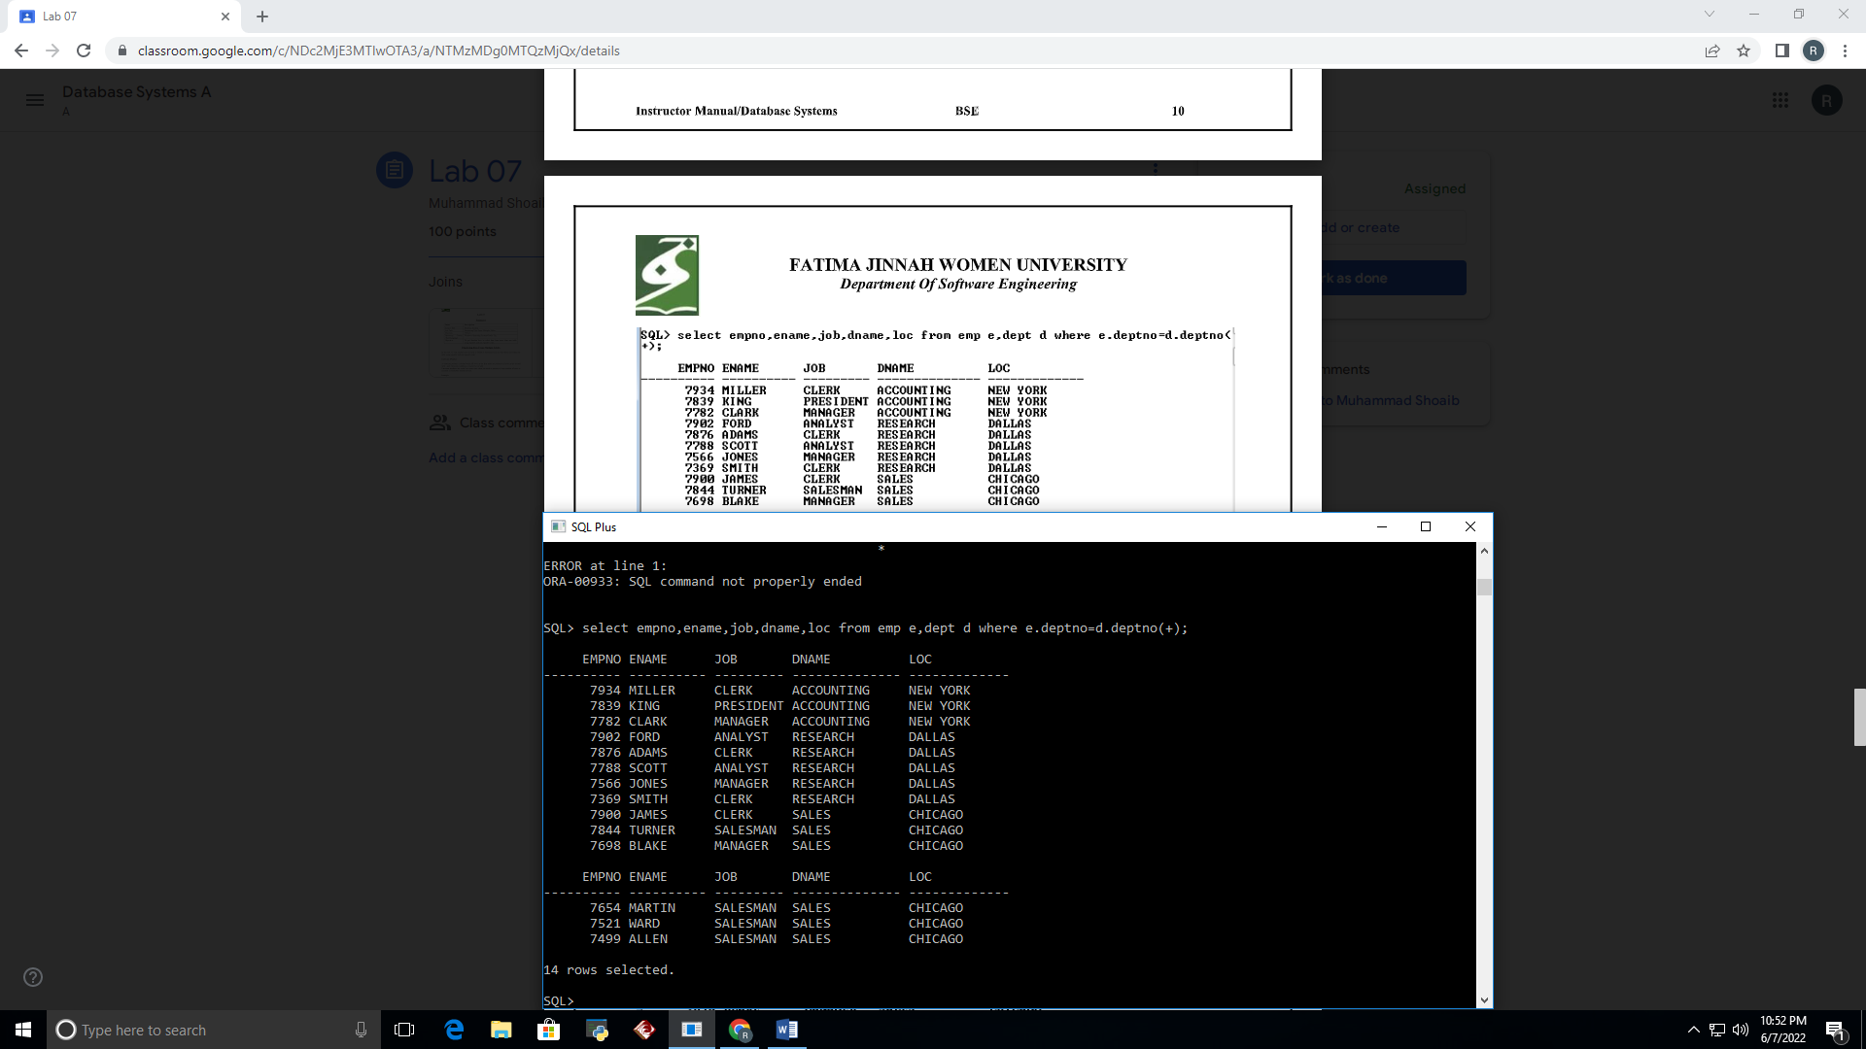

TASKS

1. Write a query to display the last name, department number, and department name for all employees.

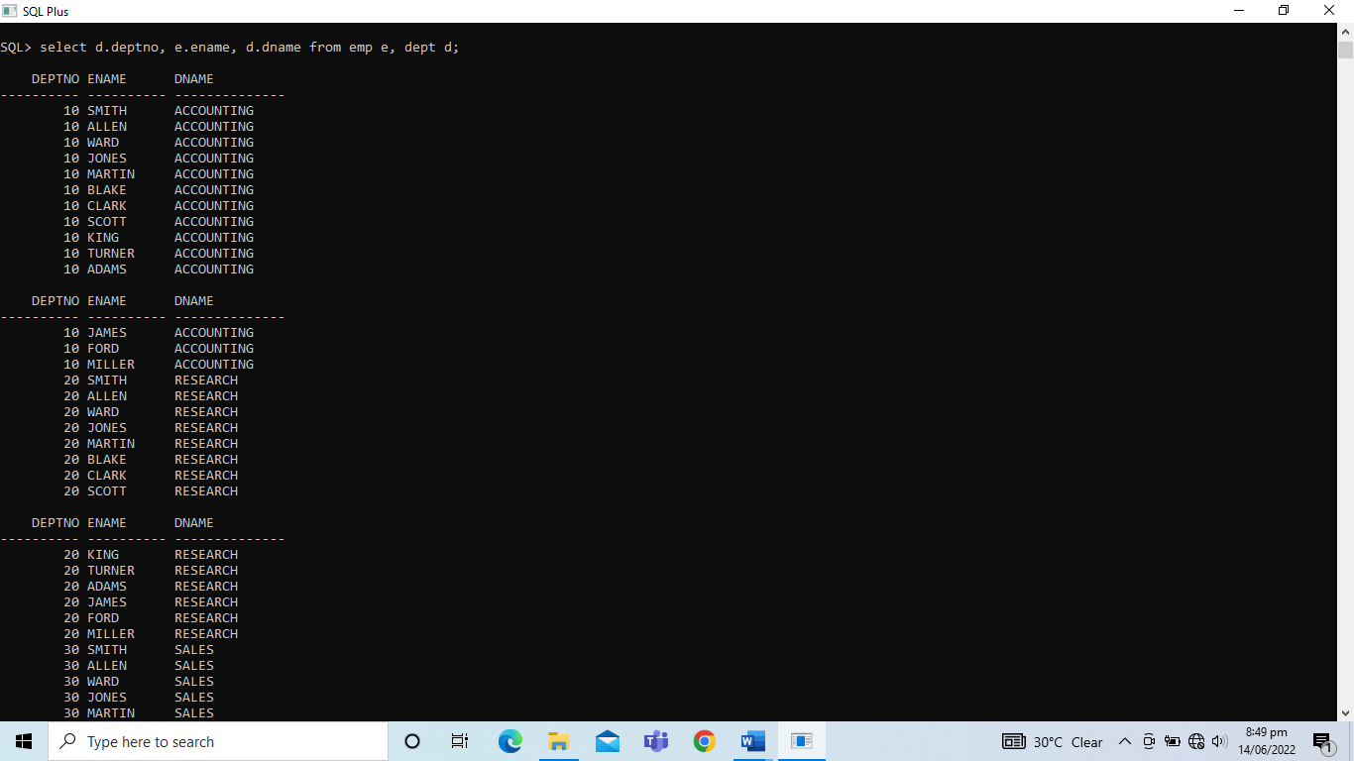

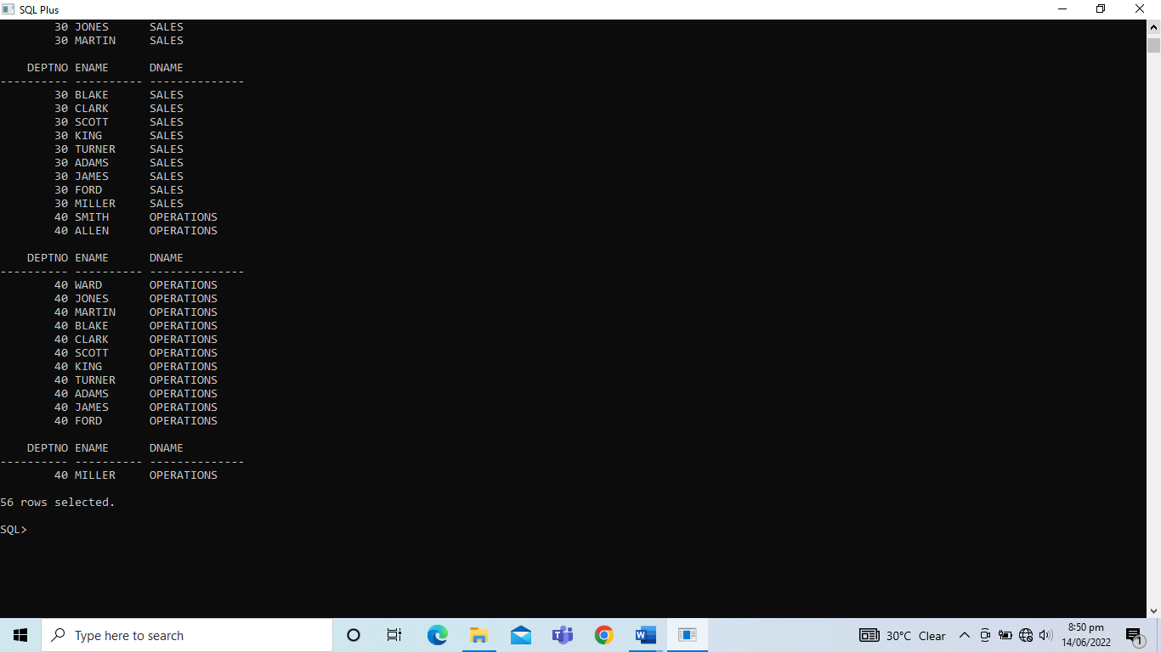

1. Create a unique listing of all jobs that are in department 30. Include the location of department 40 in the output.

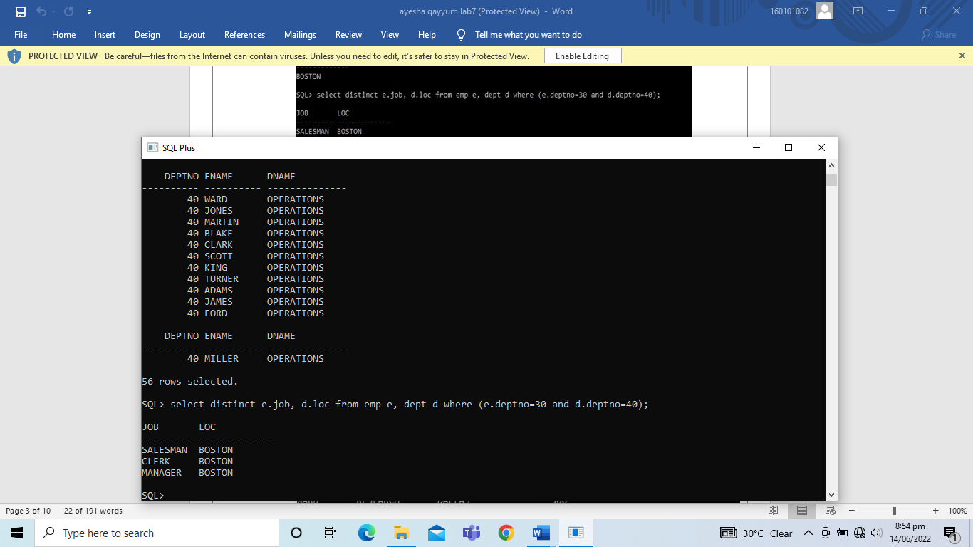

1. Write a query to display the employee name, department name and location of all employees who earn a commission.

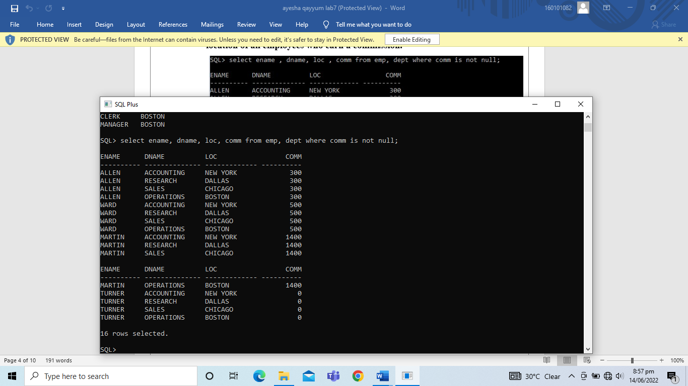

1. Display the employee name and department name for all employees who have an ‘a’ in their name.

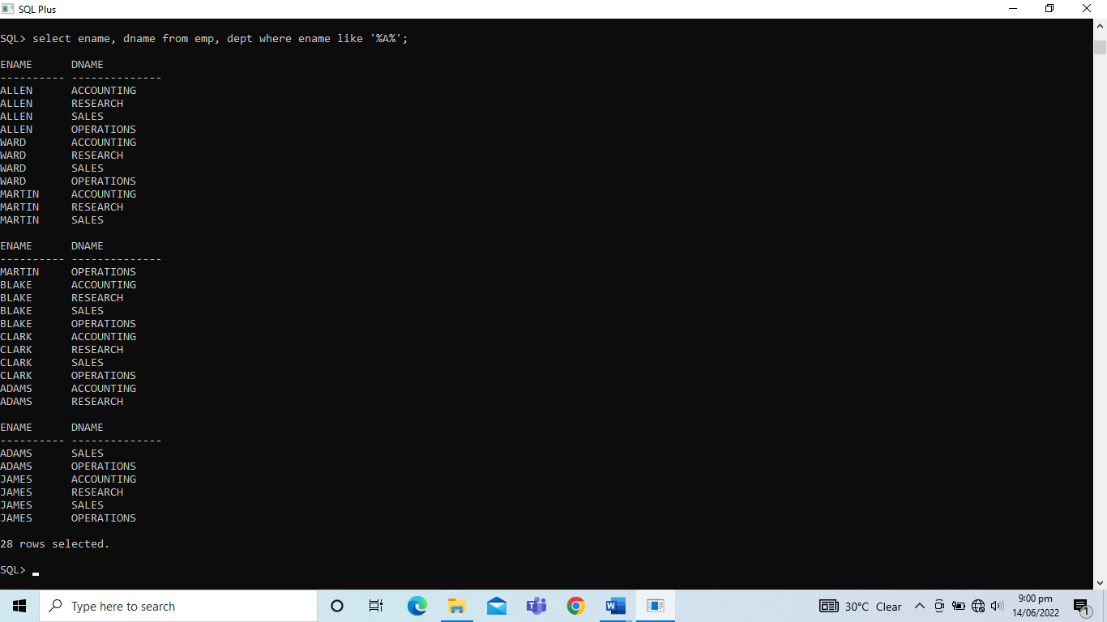

1. Write a query to display the employee name, job, department number and department name for all employees who work in ‘DALLAS’.

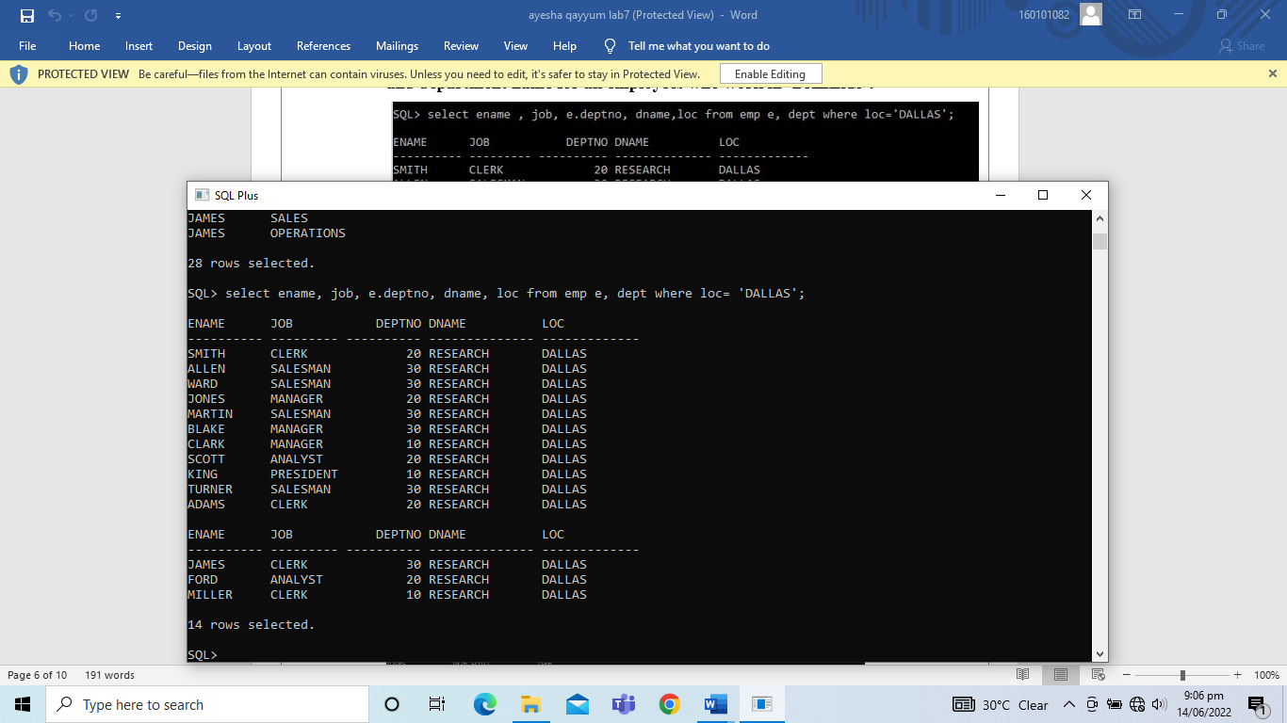

1. Display the employee name and employee number along with their manager name and manager number. Label the columns Employee, Emp #, Manager and Mgr # respectively.

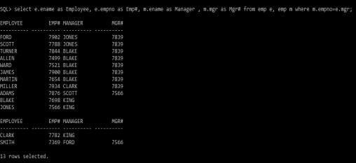

1. Modify the above query to display all employees including King, who has no manager. Order the results by employee number.

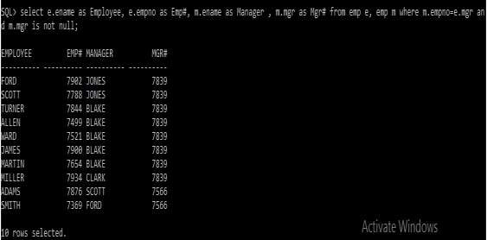

1. Create a query that displays the employee name, department number, and all the employees who work in the same department as a given employee. Given each employee an appropriate label.

